Supplementary materials
Table S1. Ingredient and chemical composition of the diets fed during the prepartum and postpartum periods
Item | Prepartum | Postpartum
Ingredients, % of DM
Corn grain, ground | 12.41 |  | 13.39
Steam-flaked corn | 7.15 |  | 11.93
Soybean meal | 8.64 |  | 13.68
Wheat bran | 5.30 |  | 0.00
Beet pulp | 6.70 |  | 9.26
Corn silage | 25.39 |  | 21.05
Alfalfa | 6.78 |  | 16.86
Oat Hay | 18.08 |  | 5.62
Sodium bicarbonate | 0.40 |  | 0.72
Calcium hydrophosphate | 0.40 |  | 0.48
Limestone, ground | 0.60 |  | 0.66
Fatty acid calcium | 0.00 |  | 0.76
Salt | 0.39 |  | 0.46
Premix¹ | 0.37 |  | 0.44
Mycotoxin binder | 0.05 |  | 0.07
Active yeast | 0.00 |  | 0.07
Brewer’s grains | 7.34 |  | 4.55
Composition, % of DM
Crude protein | 11.0 |  | 17.5
Neutral detergent fiber | 48.5 |  | 37.1
Acid detergent fiber | 27.6 |  | 20.8
Crude ash | 8.0 |  | 7.8
Calcium | 0.60 |  | 1.10
Phosphorus | 0.40 |  | 0.41
Net energy for lactation, Mcal / kg DM | 1.38 |  | 1.63
¹ Formulated to contain (per kilogram of premix) 220 to 400 KIU of vitamin A, 50 to 100 KIU of vitamin D3, ≥2250 IU of vitamin E, ≥40 mg of D-Biotin, ≥380 mg of niacinamide, ≥40 mg of beta-carotene, 0.2 to 0.7 g of Cu, 1.0 to 3.8 g of Zn, 0.8 to 3.0 g of Mn, 12.5 to 100 mg of I, 8.0 to 25 mg of Se, 2.5 to 50 of mg Co, 10.0 to 30.0% of Ca, 10.0 to 30.0% of NaCl, and ≥1.5% of total phosphorus, and ≤ 10% water.

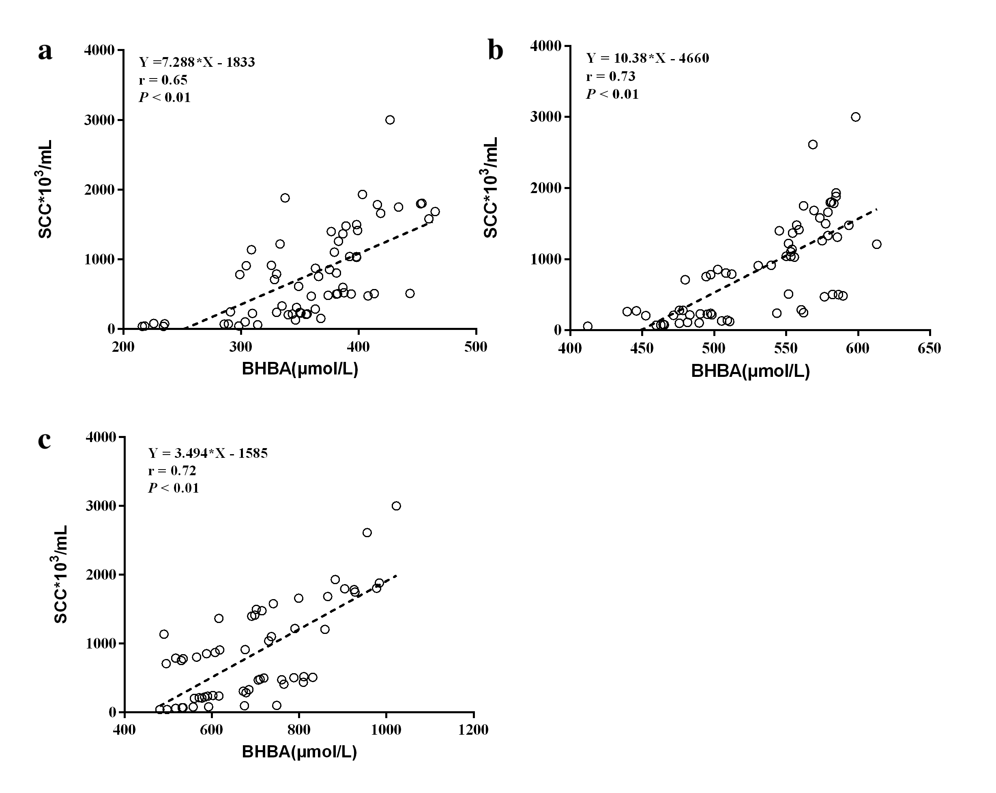
Figure S1. Correlation between somatic cell count (SCC) and β-hydroxybutyric acid (BHBA) in dairy cows at -4w (a), -3w (b), and -1w (c) relative to calving. N = 76
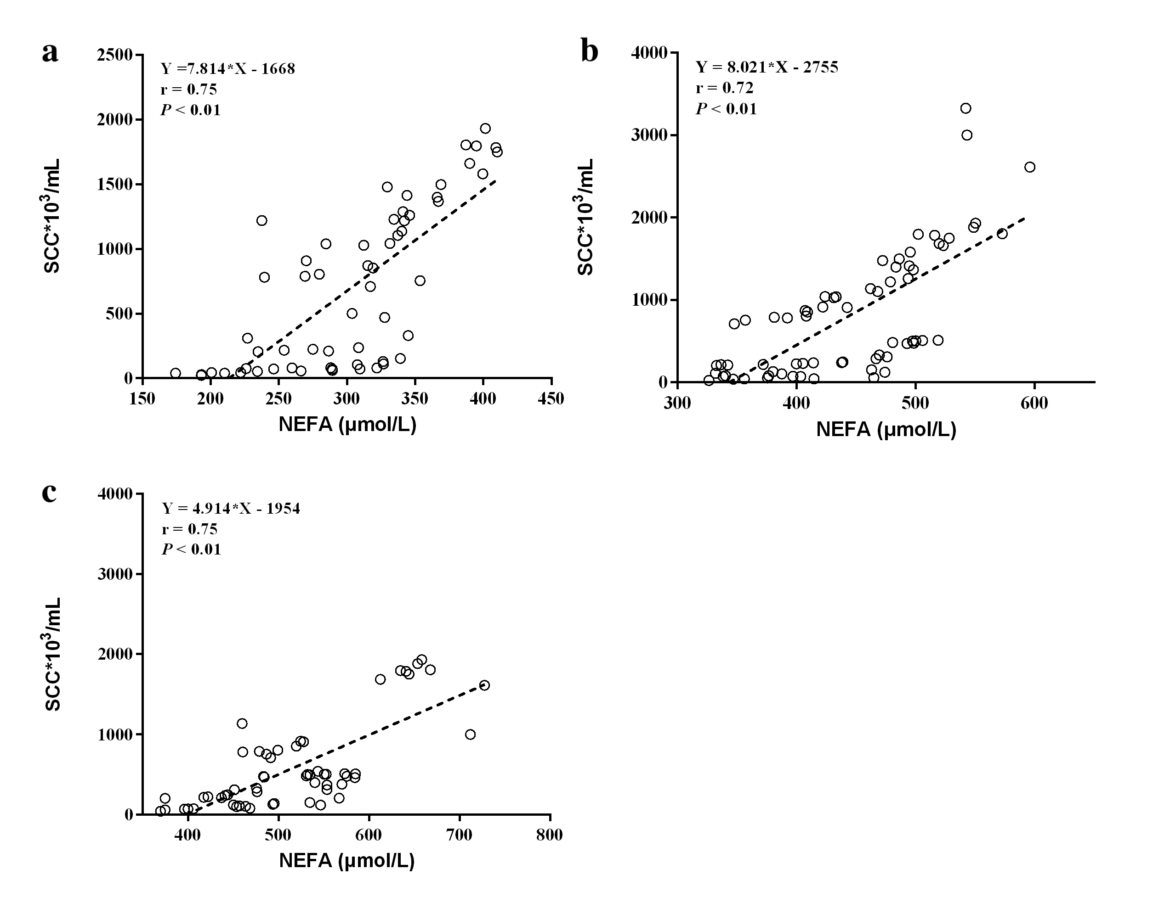
Figure S2. Correlation between somatic cell count (SCC) and non-esterified acid (NEFA) in dairy cows at -4w (a), -3w (b), and -1w (c) relative to calving. N = 76
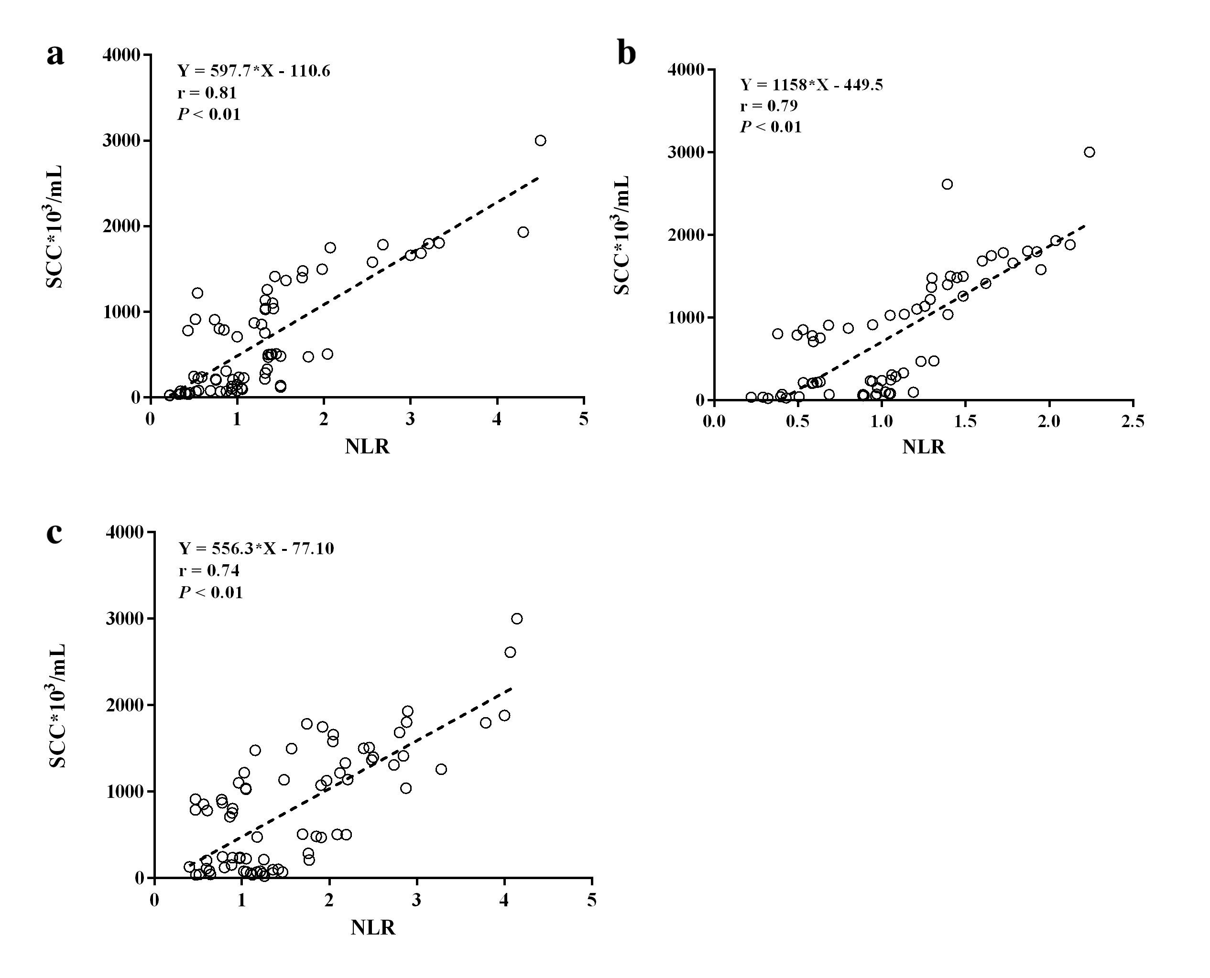
Figure S3. Correlation between somatic cell count (SCC) and neutrophil-to-lymphocyte ratio (NLR) in dairy cows at -4w (a), -3w (b), and -1w (c) relative to calving. N = 76
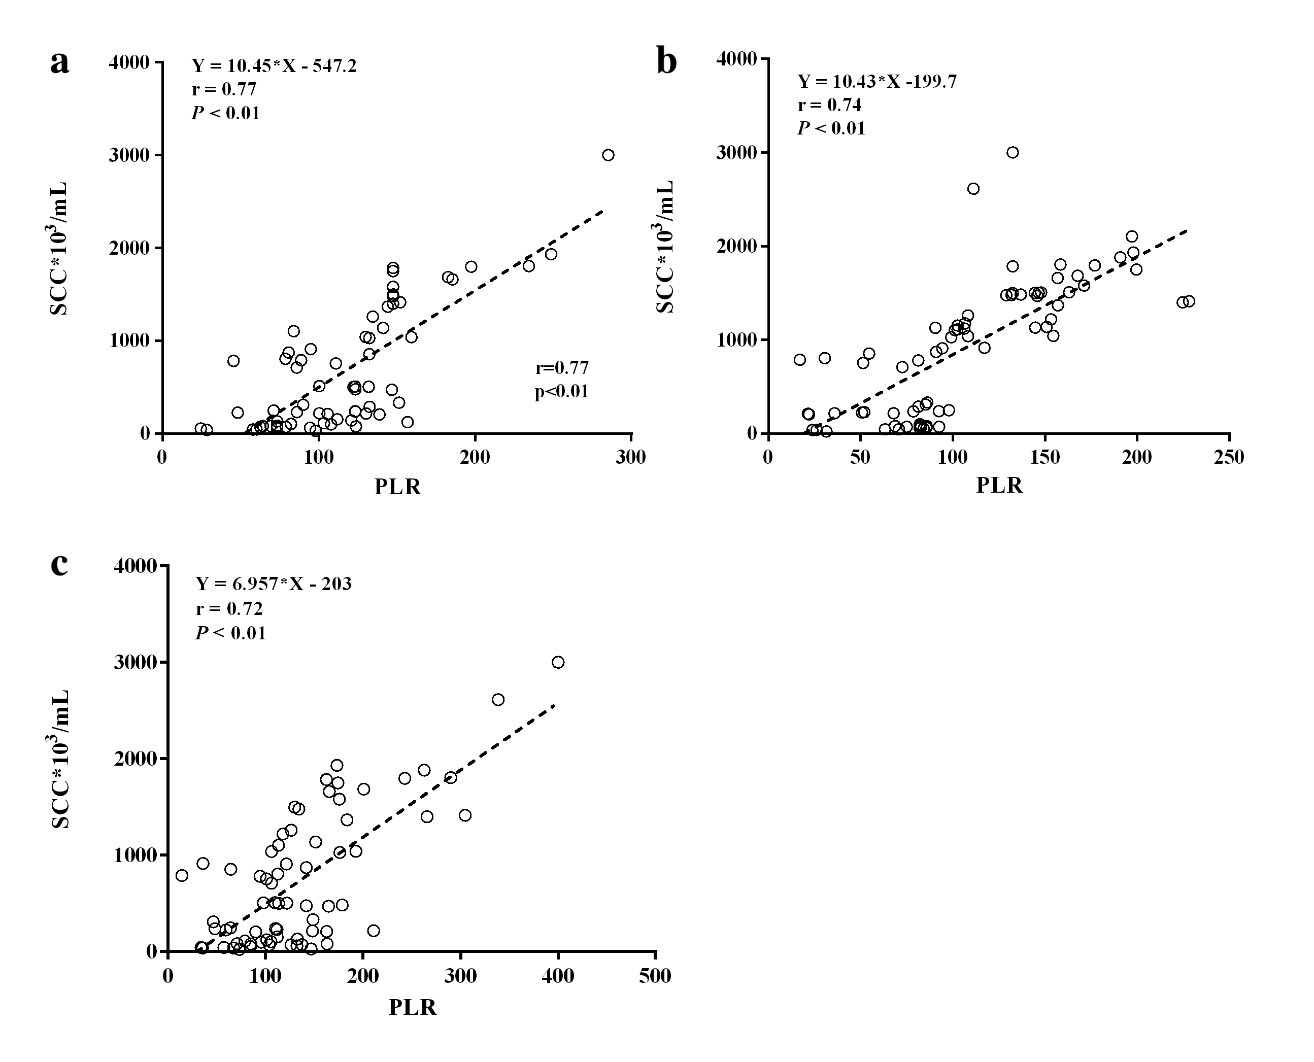
Figure S4. Correlation between somatic cell count (SCC) and platelet-to-lymphocyte ratio (PLR) in dairy cows at -4w (a), -3w (b), and -1w (c) relative to calving. N = 76
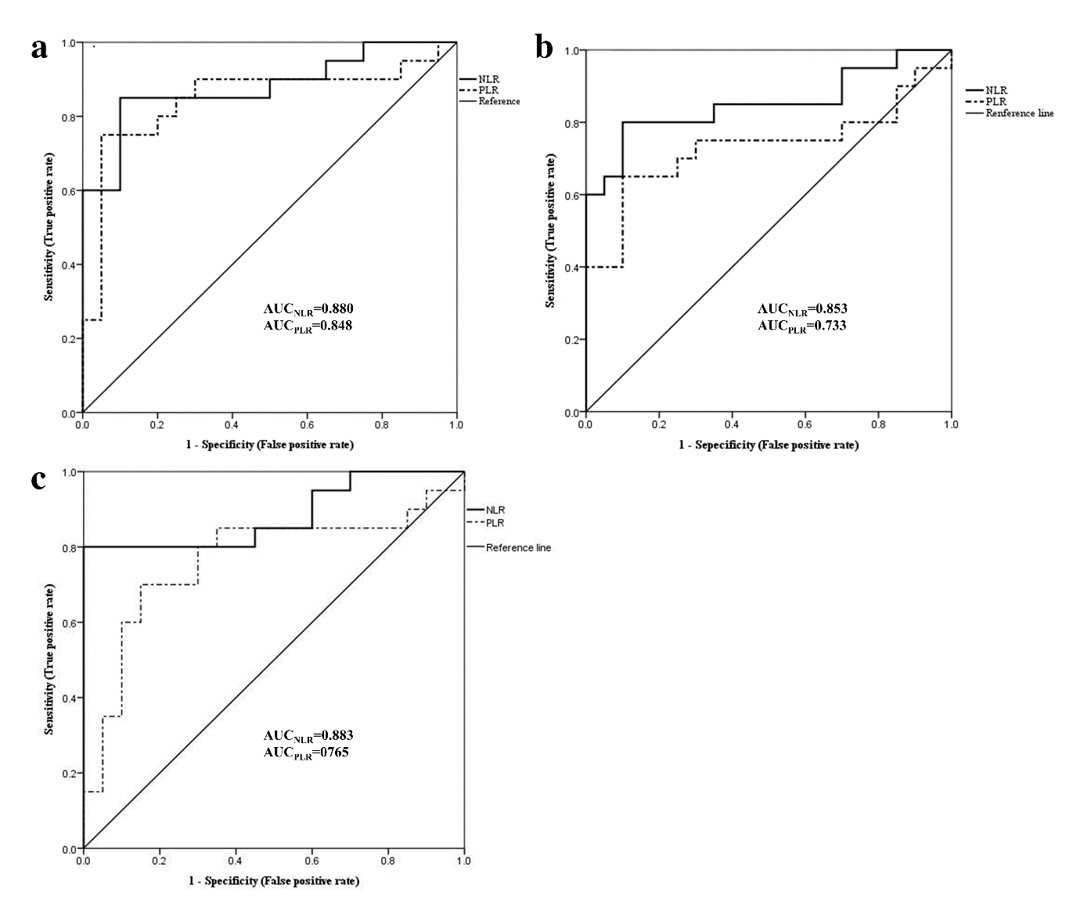
Figure S5. Receiver-operator characteristic curves of blood neutrophil-to-lymphocyte ratio (NLR) and blood platelet to-lymphocyte ratio (PLR) in dairy cows with low (LSCC) and high somatic cell count (HSCC) at -4w (a), -3w (b), and -1w (c) relative to calving. N_{(LSCC)}=23, N_{(HSCC)}=33; AUC, area under the curve
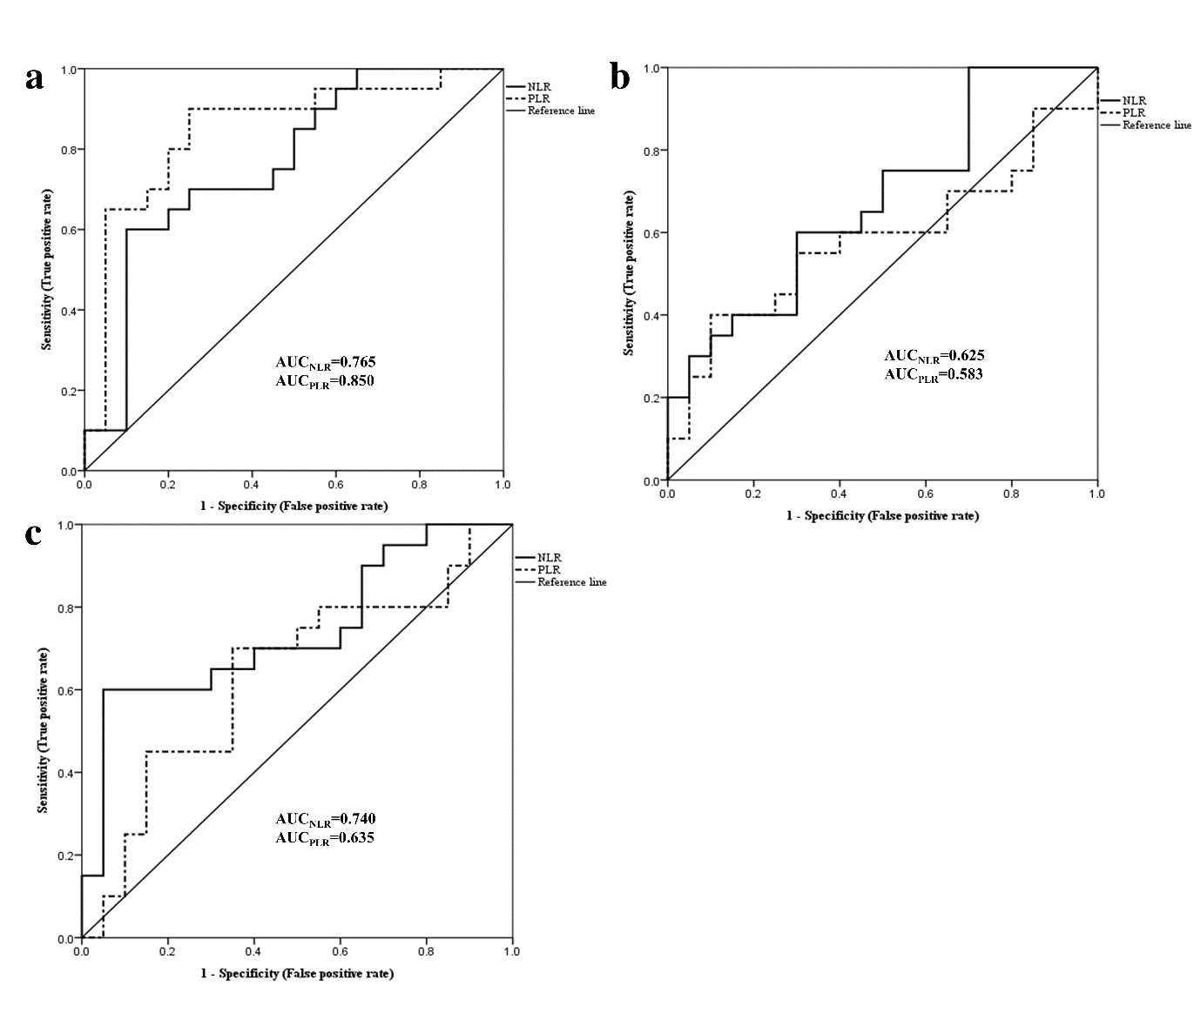Figure S6. Receiver-operator characteristic curves of blood neutrophil-to-lymphocyte ratio (NLR) and blood platelet to-lymphocyte ratio (PLR) in dairy cows with low (LSCC) and middle somatic cell count (MSCC) at -4w (a), -3w (b), and -1w (c) relative to calving. N_{(LSCC)}=23, N_{(MSCC)}=20; AUC, area under the curve.
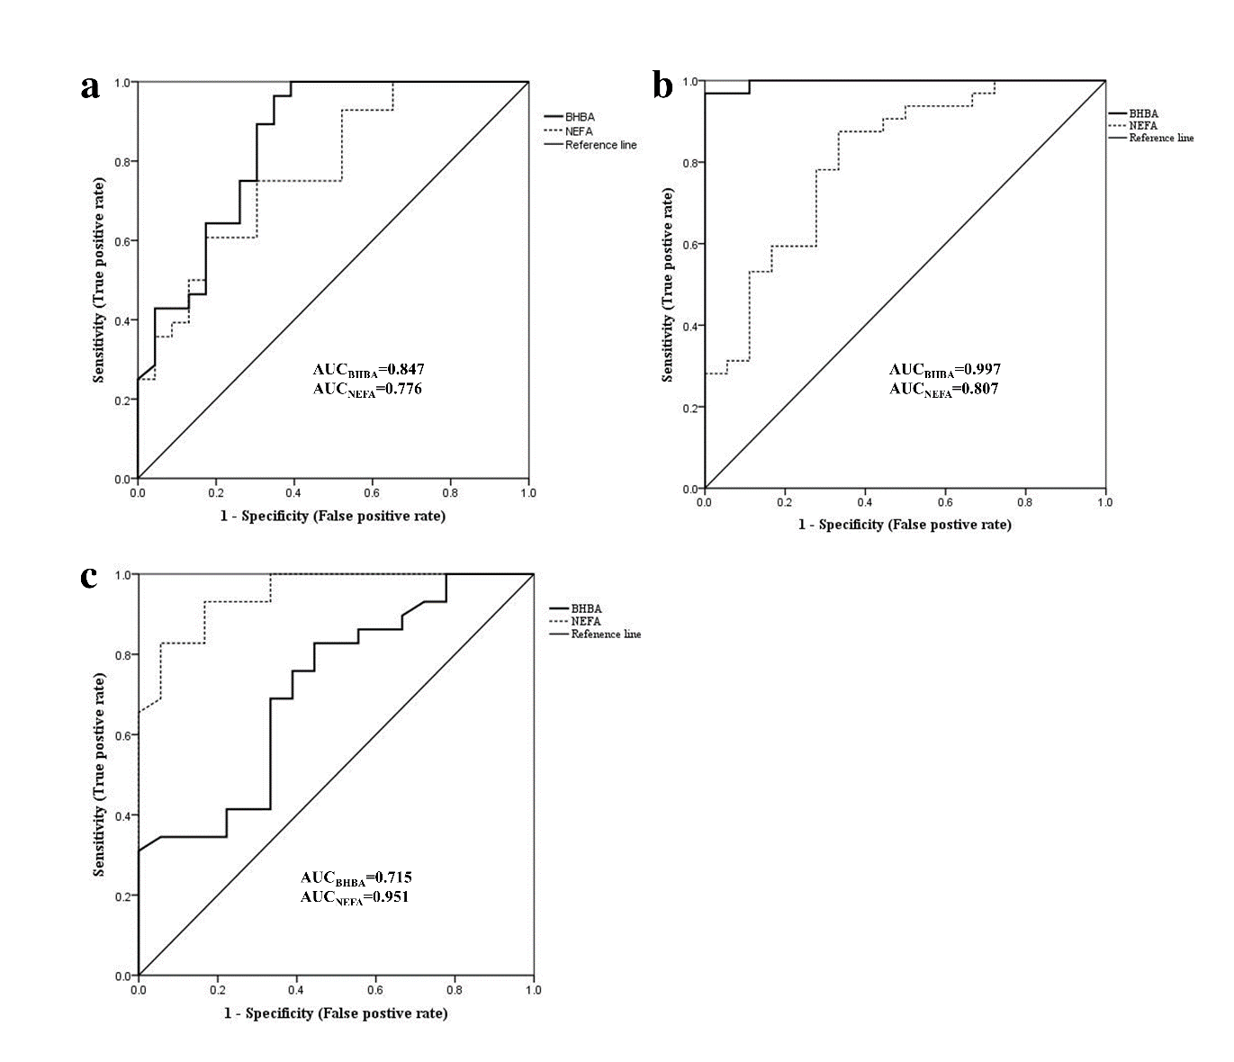
Figure S7. Receiver-operator characteristic curves of lipid metabolism analytes in dairy cows with low (LSCC) and high somatic cell count (HSCC) at -4w (a), -3w (b), and -1w (c) relative to calving. N_{(LSCC)}=23, N_{(HSCC)}=33; AUC, area under the curve; BHBA, β-hydroxybutyrate; NEFA, non-esterified fatty acid.
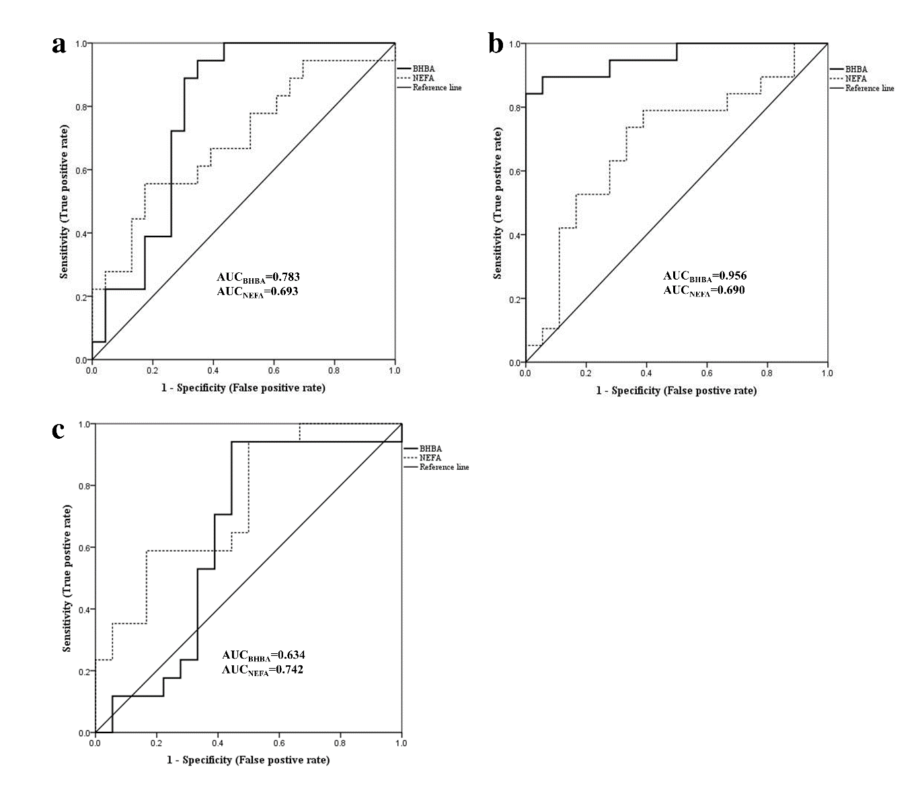
Figure S8. Receiver-operator characteristic curves of lipid metabolism analytes in dairy cows with low (LSCC) and middle somatic cell count (MSCC) at -4w (a), -3w (b), and -1w (c) relative to calving. N_{(LSCC)}=23, N_{(MSCC)}=20; AUC, area under the curve; BHBA, β-hydroxybutyrate; NEFA, non-esterified fatty acid.
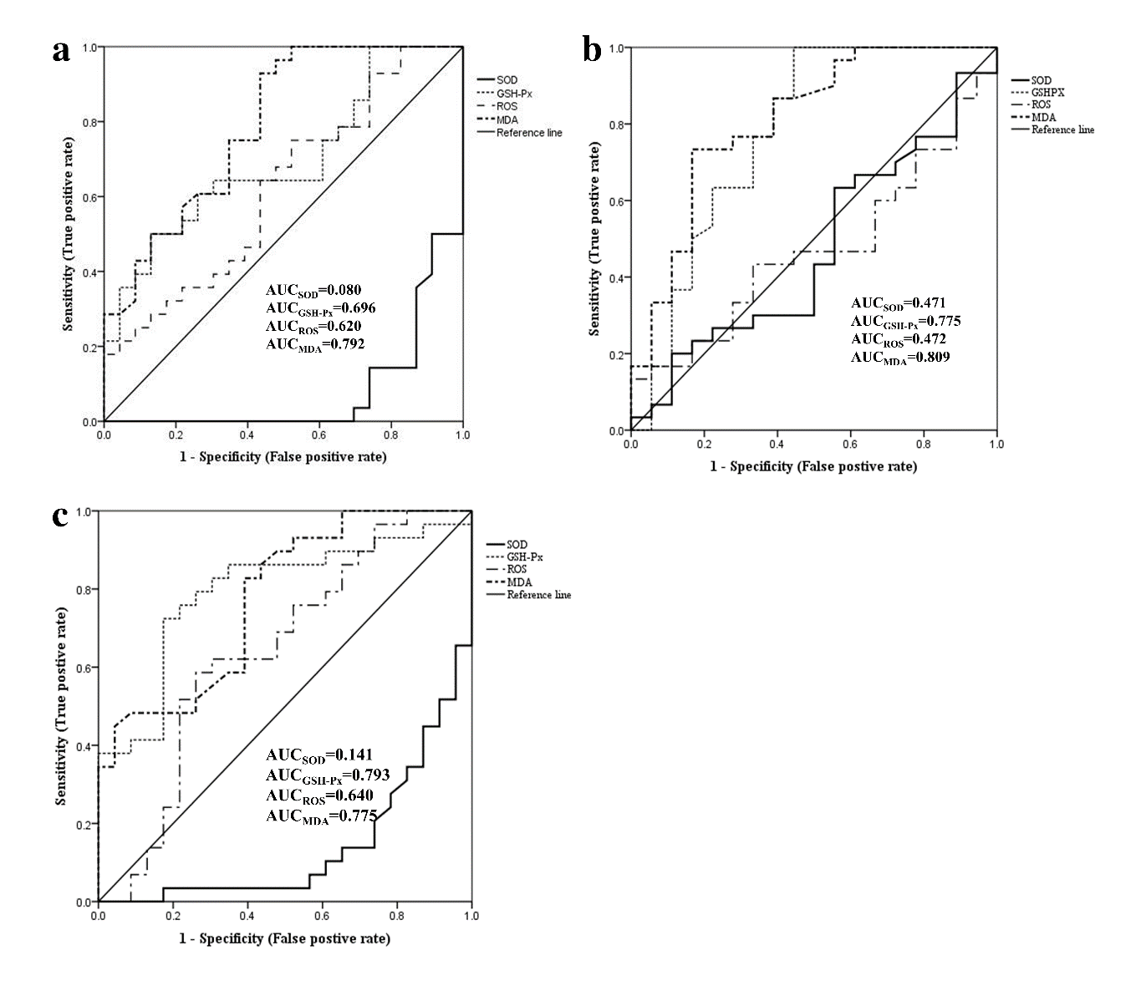
Figure S9. Receiver-operator characteristic curves of serum anti-oxidative analytes in dairy cows with low (LSCC) and high somatic cell count (HSCC) at -4w (a), -3w (b), and -1w (c) relative to calving. N_{(LSCC)}=23, N_{(HSCC)}=33; AUC, area under the curve; GSH-Px, glutathione peroxidase; MDA, malondialdehyde; ROS, reactive oxygen species (ROS); SOD, serum superoxide dismutase.
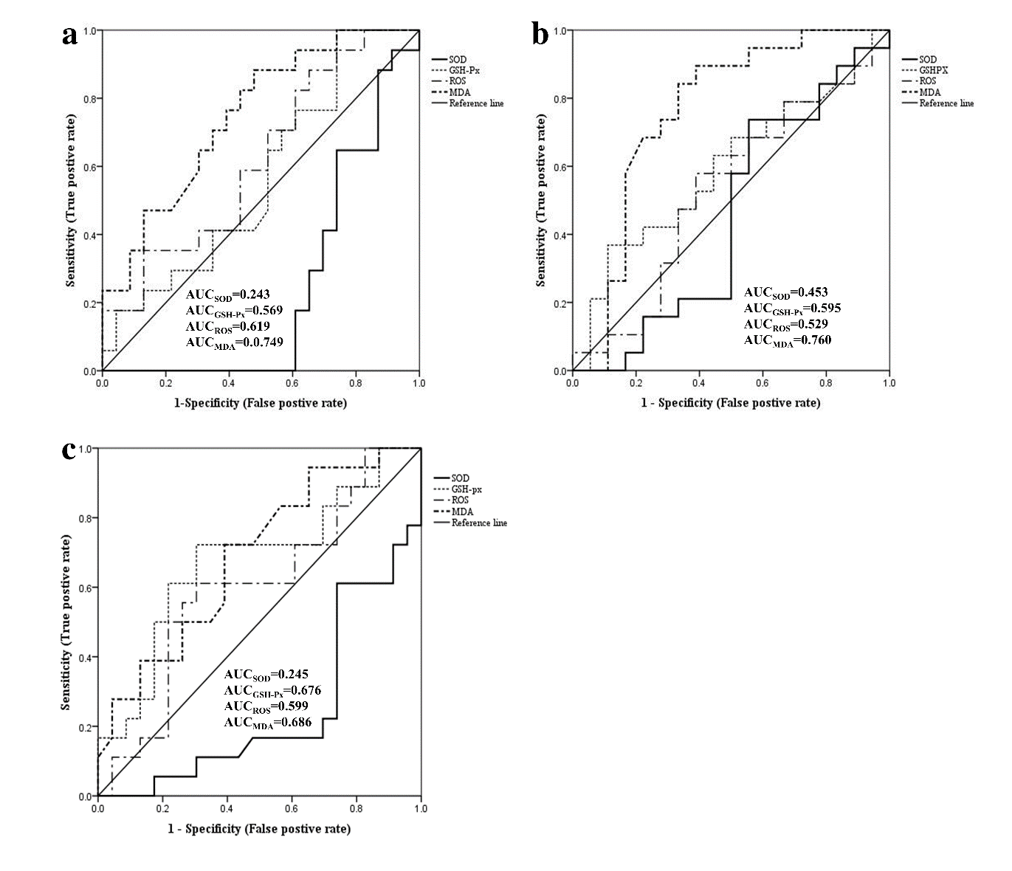
Figure S10. Receiver-operator characteristic curves of serum anti-oxidative analytes in dairy cows with low (LSCC) and middle somatic cell count (MSCC) at -4w (a), -3w (b), and -1w (c) relative to calving. N_{(LSCC)}=23, N_{(MSCC)}=20; AUC, area under the curve; GSH-Px, glutathione peroxidase; MDA, malondialdehyde; ROS, reactive oxygen species (ROS); SOD, serum superoxide dismutase.

